**Seaborn**

**Boxplot Graph Explanation:**

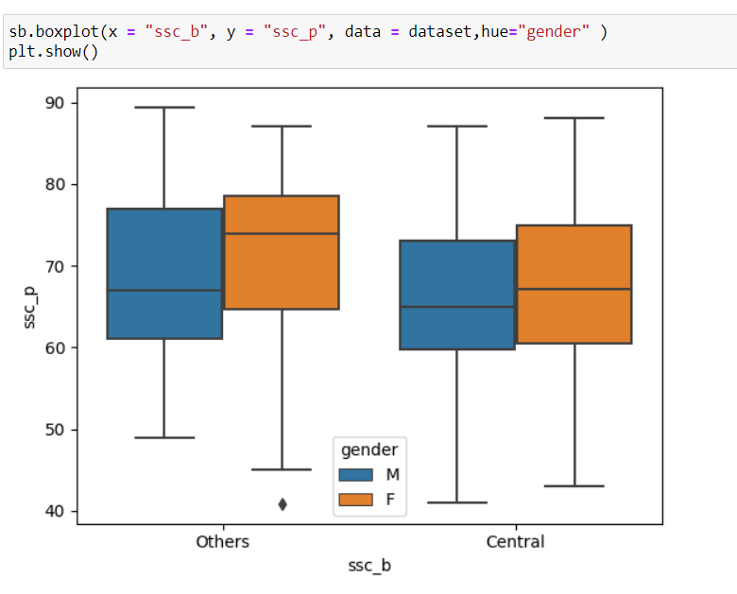

X-axis talks about the ssc _b of both the Central and Others board students nd the y-axis talks about the ssc_p mark ,both axis commonly plot with the same dataset value ie gender

In Others Board , ssc_p mark of Male students mark starts from 50 ,average of students getting upto 60 – 77 and the highest mark is 90 .

* In Others board , ssc_p mark of Female students mark starts from 45 ,average of students getting upto 65-80 and the highest mark is 80 .
* In Central board,ssc_p mark of Male students mark starts from 40 ,average of students getting upto 60 - 75 and the highest mark is 85 .
* In Central board,ssc_p mark of Female students mark starts from 43 ,average of students getting upto 62 - 75 and the highest mark is 86 .
* Overall performance in others board Male students got high mark than Female students
* Overall performance in Central board Female students got high mark than Male students
* From the boxplot we also find out percentile values Q1,Q2,Q3,Q4.
* This the summarize of boxplot .